Drawing & Painting Courses for adults with Damian Callan
Autumn 2018

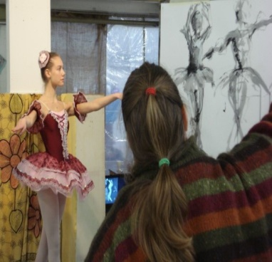

*FIGURE DRAWING & PAINTING
*FIGURATIVE COMPOSITION
*LIFE DRAWING
*PLEIN AIR PAINTING

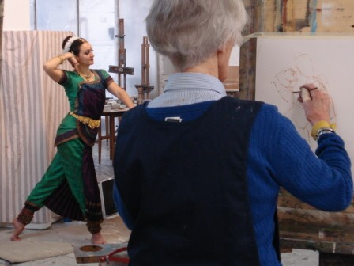

www.damiancallan.com
07951 878 560
LOCATIONS & PORTRAITS
MONDAYS 10 – 4
10th Sept – 3rd Dec
(15th Oct half term)
This exciting course will guide students from the sketchbook study to the finished canvas. Working with models both on location and in the studio, students will explore different themes and develop their own approaches to composing figurative paintings. Beginning with drawing on location, students will gather information using a variety of drawing media : charcoal, ink and oil pastels. In the studio students will learn how to develop them into painted compositions using oils, acrylics, or chalk pastels.
A recent location was the Union Canal at Lochrin Basin. Our model held 3o minute canal worker poses and students were introduced to working in ink and wash to explore the use of line and tone in drawing. A slide presentation in the studio looked at the work of L S Lowry and Van Gogh as inspiration for the painted compositions.

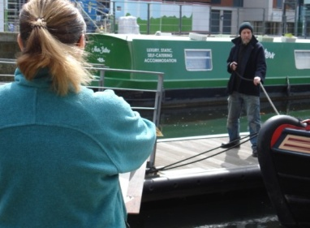

Locations include:
Museum Musical Instruments
Murrayfield Ice Rink
Roslin Chapel
Lyceum Theatre Wardrobe
Museum of Scotland
Edinburgh’s Christmas

COST £420 FOR 12 WEEKS
DRAWING & PAINTING
THE FIGURE
WEDNESDAYS 9 45 - 4
12th Sept – 5th Dec
(17th Oct mid – term)
In this studio based class students learn to develop their own ways of drawing and painting the human figure. Each session begins with a slide presentation or demonstration related to the theme and subjects including portraiture, composition, narrative and colour
Working for 2 weeks on the theme ‘Night Scene’ provided an opportunity to work with a dramatically lit set up and make connections between tone and colour. A slide presentation at the start looked at the paintings of Rembrandt and Vuillard for inspiration.

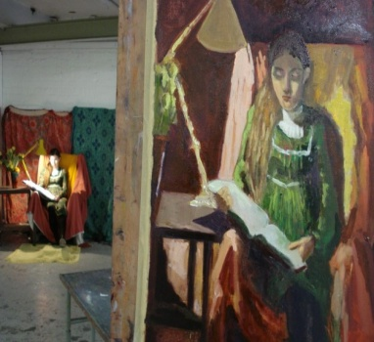

COST £420 FOR 12 WEEKS

Themes include: Painting Eyes, Square and Double Square, Cafe Scene, Hands and Feet, Colour: Limited Palette, Expressive Techniques.

ALSO:
Wednesday Evenings 7 – 9 45
COST £210 FOR 12 WEEKS
SATURDAY WORKSHOPS
Heads: Older and Younger!
Working with both older and younger models these workshops can be taken individually or as a set.
29th September
Black & White Heads
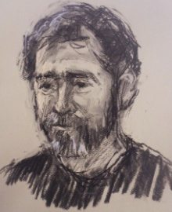
27th October
Heads in Colour
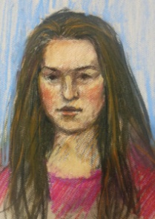
24th November
Mixed Media Heads
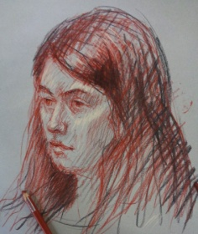

COST £60 EACH OR £150 FOR ALL THREE
Studio address:
WASPS Studios
2West Park Place
Dalry, EH11 2DP
All materials provided
...........................................
BOOKING FORM
Yes, please! Reserve me a place on
Mondays LOCATIONS & PORTRAITS 
Wednesdays DRAWING & PAINTING THE FIGURE
Day class 
Wednesdays DRAWING & PAINTING THE FIGURE
Evening class 
SATURDAY WORKSHOPS
29th Sept....
27th Oct....
24th Nov....
CONTACT DETAILS:

I enclose a cheque payable to Damian Callan
147/4 Dalkeith Road
EH16 5HQ or BACS:
D O CALLAN
80-02-24
00227215
Damian Callan is a practising figurative artist who has taught children & adults at eca, Leith School of Art & The Natiuonal Gallery

